

24ADC001- BUSINESS INTELLIGENCE

--------------------------------------------------

2026-2027
LAB RECORD

DEPARTMENT OF ARTIFICIAL INTELLIGENCE AND DATA SCIENCE

INDEX
Expt. No | Title of the Experiment | Page No | Total Marks | Faculty Signature
1. | Explore the interface and basic features of the BI tool
2. | Load and visualize a sample dataset.
3. | Import a dataset into the BI tool. And Cleanse data by handling missing values, outliers, and  inconsistencies.
4. | Transform data to suit BI reporting requirements and Design a dashboard with  key performance indicators (KPIs).
5. | Develop interactive dashboards for dynamic data exploration.
6. | Integrate data from various sources for comprehensive analysis
7. | Implement advanced chart types (treemaps, heatmaps, etc.).
8. | Apply BI tools for forecasting and predictive analytics.

Average marks Faculty Signature

EXPT NO:1 | EXPLORE THE INTERFACE AND BASIC FEATURES OF BI Tool
DATE: 10.07.2026

PRE-LAB QUESTIONS (PROVIDE BRIEF ANSWERS TO THE FOLLOWING QUESTIONS)

- What is the purpose of Business Intelligence (BI) tools like Tableau and Power BI?

Business Intelligence (BI) tools help collect, analyze, visualize, and present data in the form of charts, graphs, and dashboards. They enable organizations to make informed decisions by identifying trends, patterns, and insights from data.

- List any three common data sources that Tableau and Power BI can connect to.
• Microsoft Excel
• CSV (Comma-Separated Values) files
• SQL Databases (e.g., MySQL, SQL Server)

- What is a dashboard in BI, and how is it different from a single chart?
A dashboard is a collection of multiple visualizations, KPIs, filters, and reports displayed on a single screen to provide a complete view of the data.
A single chart displays only one aspect of the data, such as sales over time or stock prices, whereas a dashboard combines several charts and metrics for comprehensive analysis.

- Define the following terms:
  - Visualization
A visualization is a graphical representation of data using charts, graphs, maps, or tables to make information easier to understand.
  - KPI
A KPI is a measurable value used to evaluate how effectively a business or process is achieving its objectives.
  - Data Filter
A data filter allows users to display only the data that meets specific conditions while hiding the remaining data.

- Why is it important to clean and transform data before visualization?
Cleaning and transforming data improves data quality by removing errors, duplicates, and missing values, ensuring that visualizations are accurate, consistent, and reliable for decision-making.

- What kind of chart would you use to analyze stock price trends over time?

A Line Chart is the most suitable chart because it clearly shows how stock prices change over time and helps identify trends and patterns.

- Explain the role of slicers in Power BI and filters in Tableau.

Slicers in Power BI are interactive controls that allow users to filter data directly on the report page.
Filters in Tableau allow users to limit the displayed data based on selected conditions, making it easier to focus on specific information.
Both features make dashboards interactive and help users explore data dynamically.

- What does a calculated field or measure do in BI tools?
A calculated field or measure performs calculations using existing data to create new values, such as profit, growth rate, average stock price, or percentage change, without modifying the original dataset.

- What are the advantages of using interactive dashboards for financial data analysis?
• Provides real-time insights into financial performance.
• Helps identify trends and patterns quickly.
• Enables users to filter and explore data interactively.
• Supports faster and better decision-making.

- Which function would you use to find the absolute difference between predicted and actual stock prices?
Use the ABS() (Absolute Value) function.
Formula:
ABS(Predicted Price - Actual Price)
This returns the absolute difference (error) between the predicted and actual stock prices, regardless of whether the prediction is higher or lower than the actual value.

IN-LAB EXERCISE:
Objective:
To understand the basic interface, data import process, and fundamental visualization capabilities of Tableau and Power BI using a stock prediction dataset, and to explore their usefulness in analyzing financial data.

Tools Required:
- Tableau Public / Tableau Desktop
- Power BI Desktop
- Sample Dataset (CSV/Excel) containing:
Date, Stock Name, Open, Close, High, Low, Volume, Predicted Price

Exercise Steps:
Part 1: Working with Tableau
- Launch Tableau and connect to the stock prediction dataset.

Explore the Interface:
  - Understand components like Data Pane, Sheets, Marks Card, and Dashboards.

Create Basic Visualizations:
  - Line Chart: Show Close Price over time.
  - Scatter Plot: Plot Volume vs. Predicted Price.
  - Highlight Table: Display Predicted Price by stock.

Apply Filters:
  - Add filters for Stock Name and Date Range.

Create Calculated Field:
  - Calculate prediction error as |Predicted - Close|.

Design a Basic Dashboard:
  - Combine your charts into one interactive dashboard.

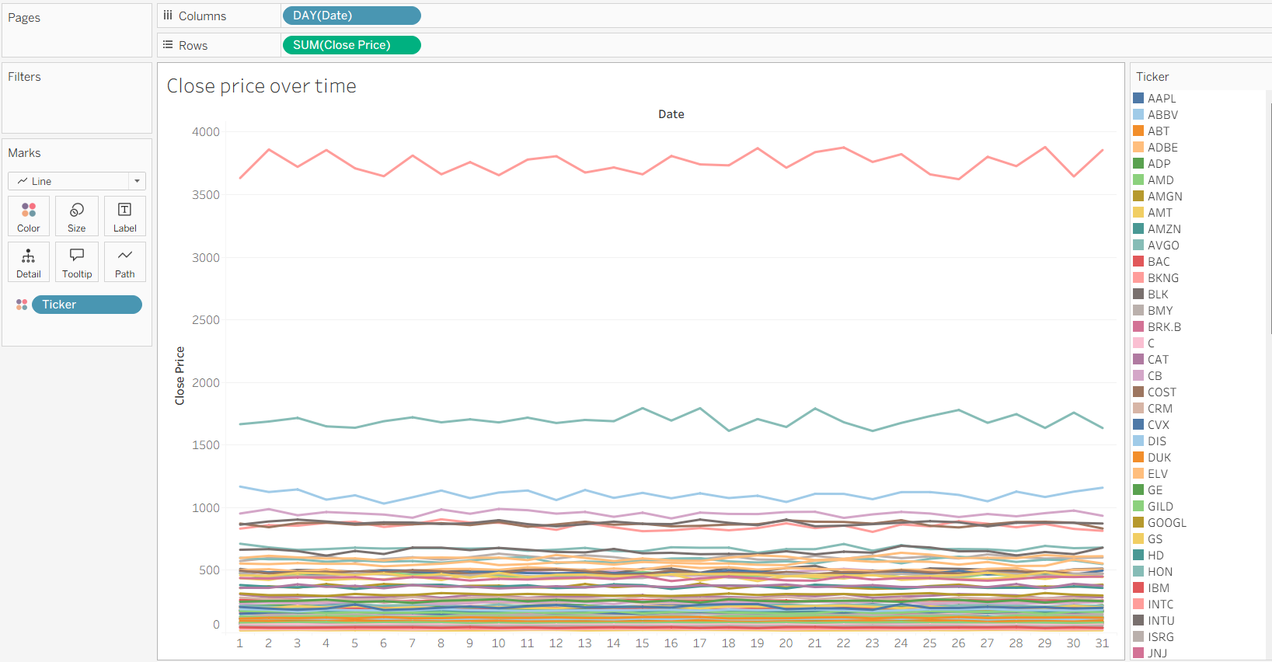

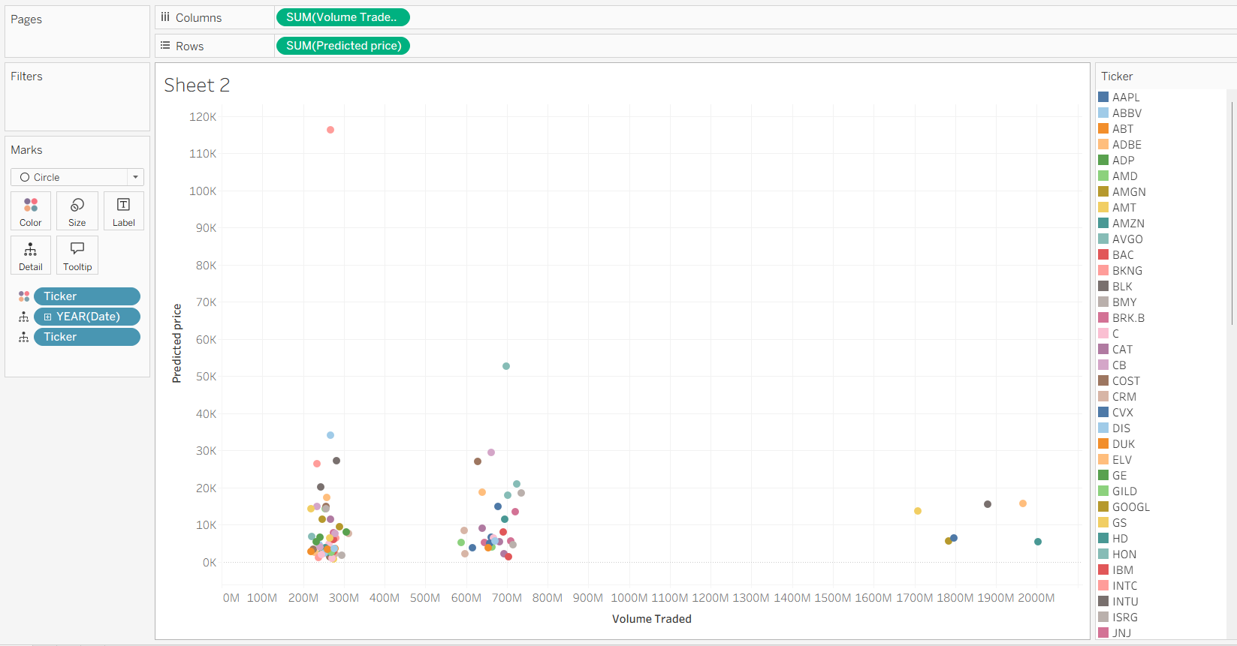

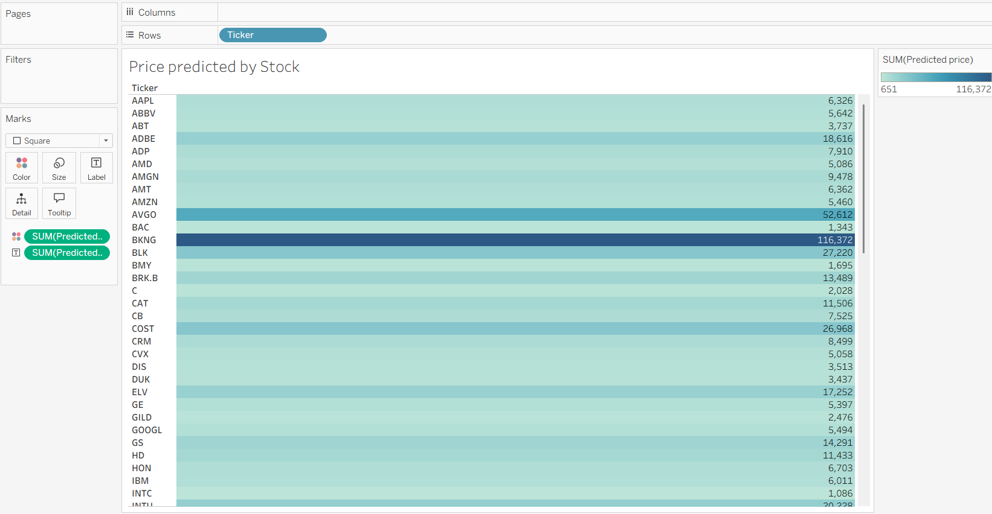

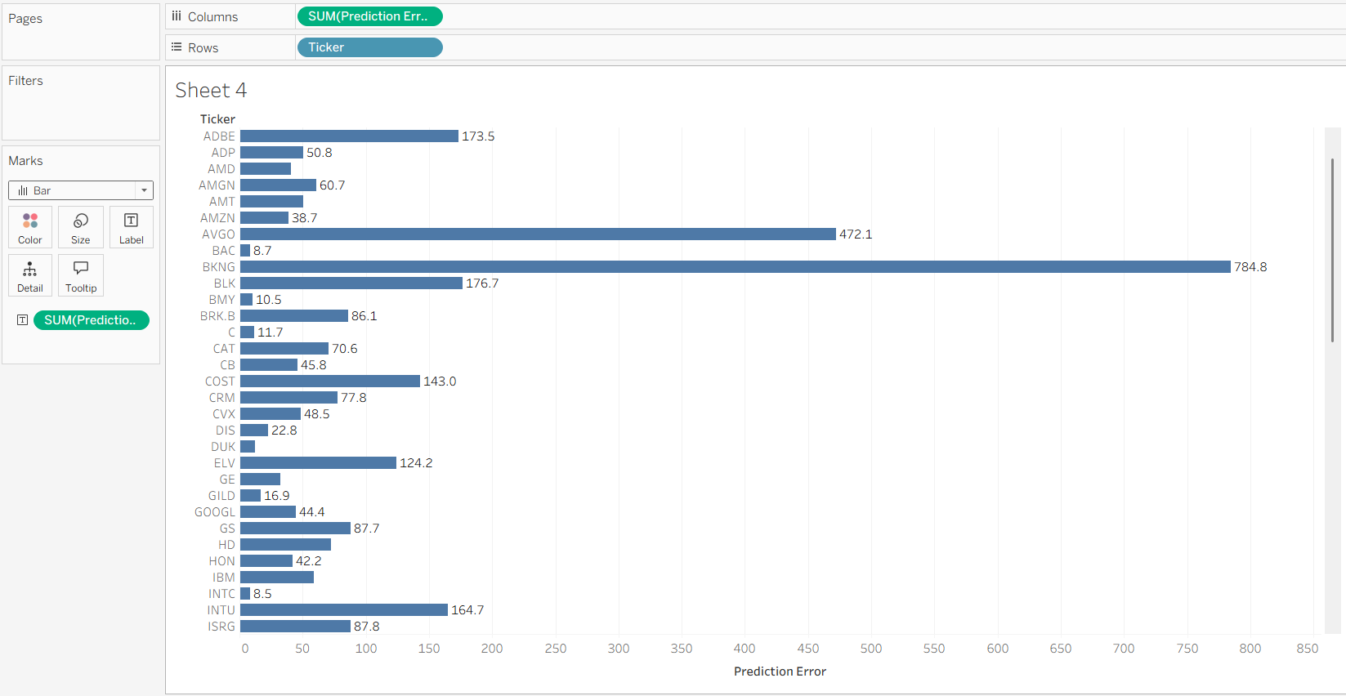

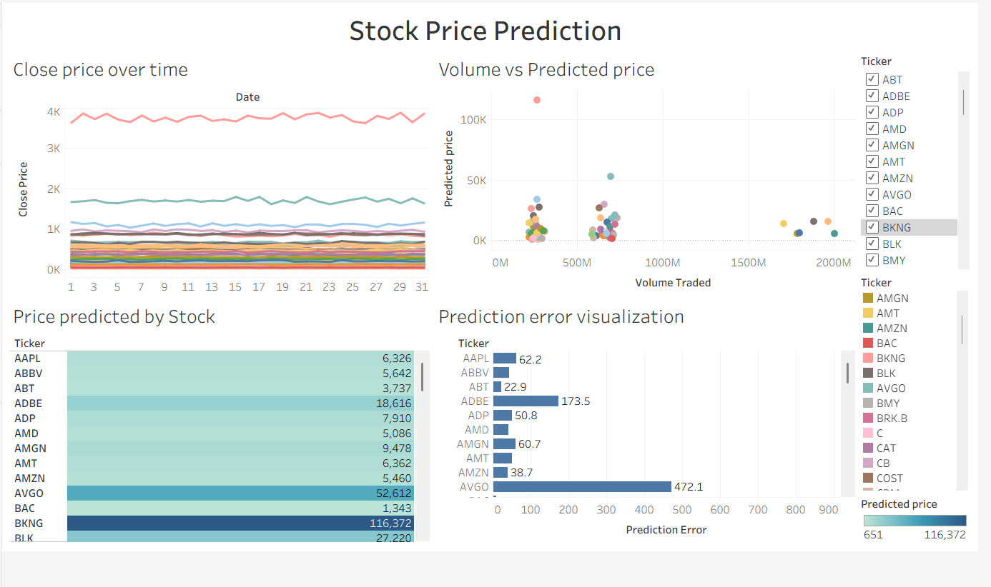

Part 2: Working with Power BI
- Open Power BI Desktop and import the same dataset.

Explore the Interface:
  - Familiarize with Fields Pane, Visualizations Pane, Report View, Data View.

Create Basic Visualizations:
  - Line Chart: Trend of Close Price over time.
  - Bar Chart: Compare Predicted Price vs. Close Price.
  - Card (KPI): Display average prediction error.

Use Filters and Slicers:
  - Filter data based on Stock Name and Date.
- Create a Simple Measure using DAX:
  - Example: Prediction Error = ABS(Predicted - Close)

Build a Report Page:
  - Arrange visuals in a single interactive page.

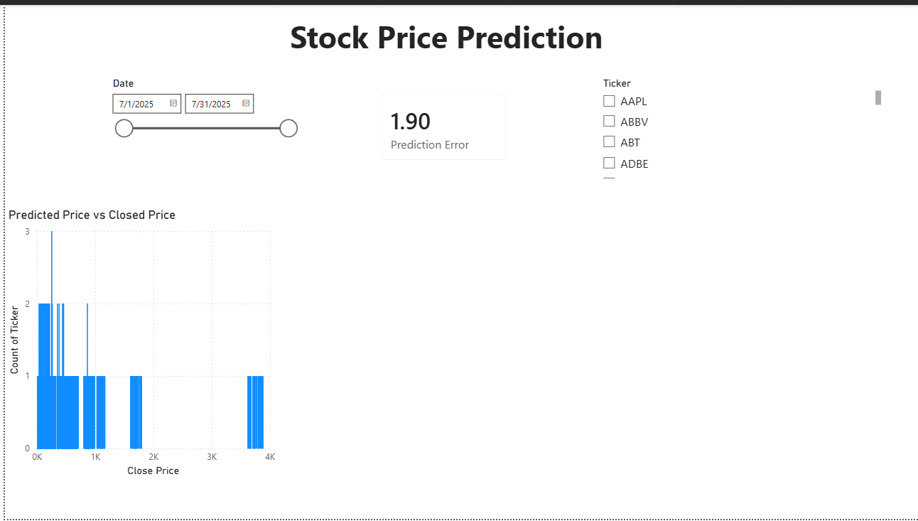

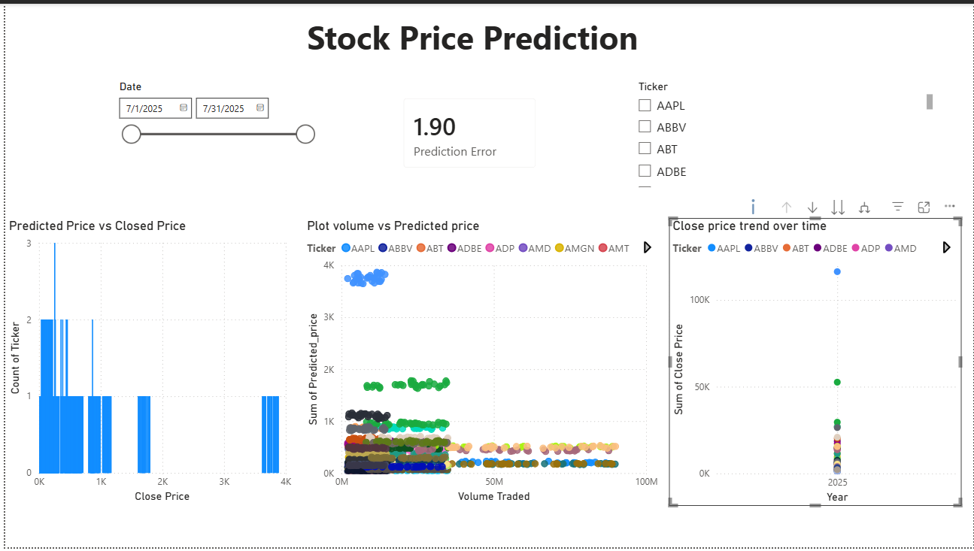

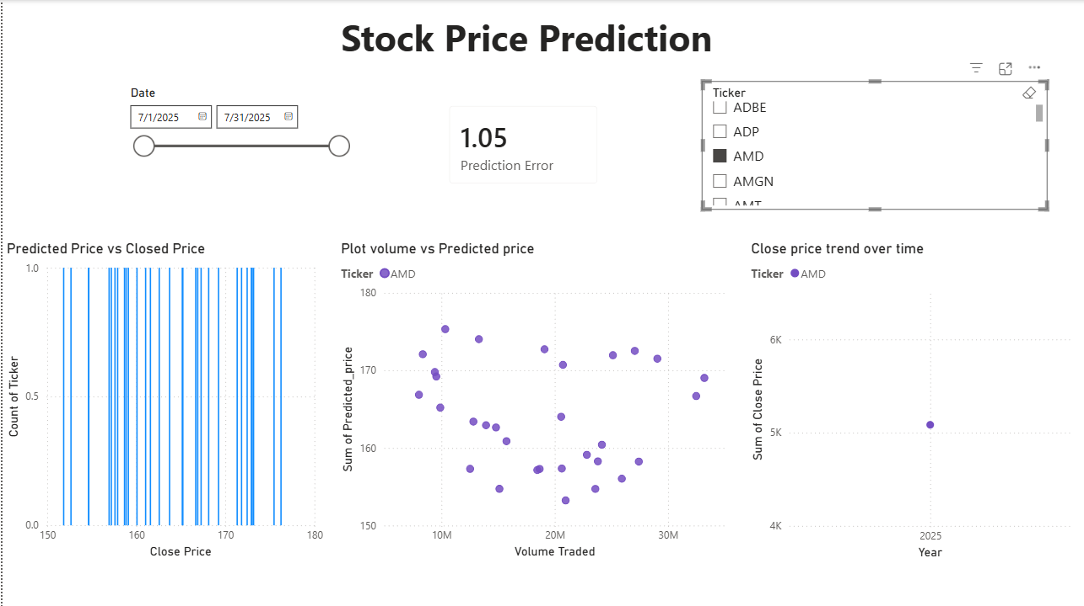

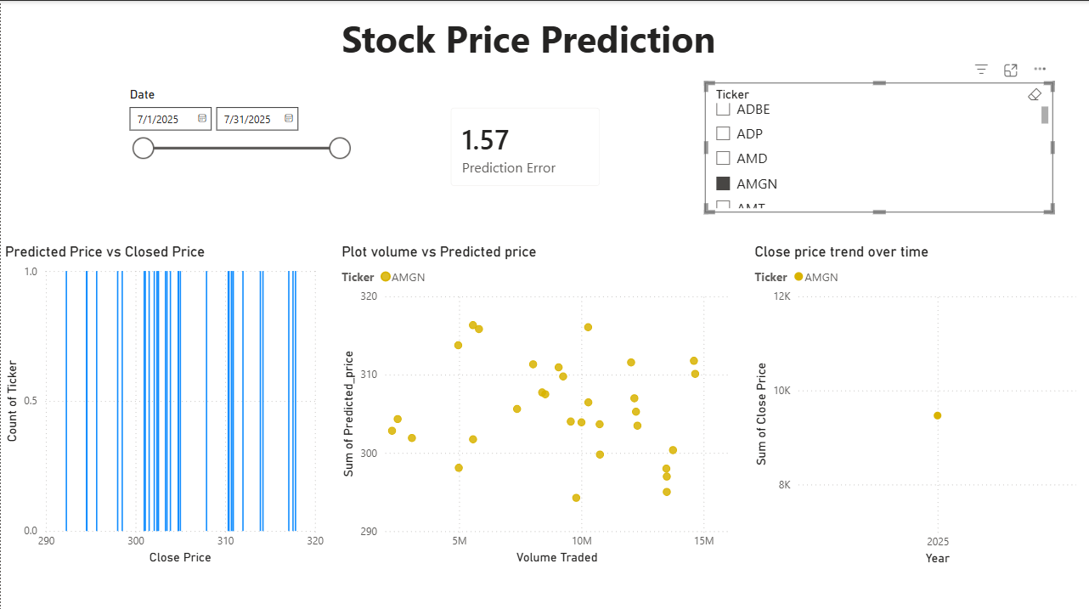

POST-LAB QUESTIONS (PROVIDE BRIEF ANSWERS TO THE FOLLOWING QUESTIONS)

1. Describe your experience with the Tableau interface. What components did you interact with?
The Tableau interface was intuitive and easy to navigate. I interacted with the Data Pane, Sheets, Rows and Columns shelves, Marks Card, and Dashboard section to create and organize visualizations.

2. How did you import the dataset into Tableau and Power BI?
In Tableau, I connected to the CSV file using Connect → Text File and loaded the dataset. In Power BI, I imported the dataset using Home → Get Data → Text/CSV and then loaded it into the report.

3. What types of visualizations did you create in both tools? List at least two per tool.
Tableau:
Line Chart (Close Price over Time)
Bar Chart (Predicted Price vs. Close Price)
Power BI:
Line Chart (Close Price Trend)
Clustered Column Chart (Predicted Price vs. Close Price)
KPI Card (Average Prediction Error)

4. How did you calculate the prediction error, and how was it displayed in your dashboard?
The prediction error was calculated as the absolute difference between the Predicted Price and the Close Price using the ABS() function. In Power BI, it was displayed as a KPI Card, showing the average prediction error.

5. Which filtering or slicing techniques did you apply, and what insights did they reveal?
I used Ticker (Stock Name) and Date slicers/filters to analyze individual stocks and specific time periods. These filters helped identify price trends and compare prediction accuracy for different stocks and dates.

6. Compare the process of creating a line chart in Tableau vs. Power BI. What differences did you notice?
In Tableau, creating a line chart involved dragging the Date field to the Columns shelf and Close Price to the Rows shelf. In Power BI, I selected the Line Chart visual first and then assigned Date to the X-axis and Close Price to the Y-axis. Tableau offers more drag-and-drop flexibility, while Power BI uses predefined visualization fields.

7. How did you organize the dashboard in Tableau and Power BI? What key elements did you include?
I arranged the dashboard with slicers at the top, followed by the line chart, bar chart, and KPI card. The dashboard included Date and Ticker filters, Close Price Trend, Predicted vs. Close Price comparison, and the Average Prediction Error.

8. Which tool (Tableau or Power BI) did you find more user-friendly for financial data visualization, and why?
I found Power BI more user-friendly because it provides easy-to-use visualizations, built-in DAX functions, and interactive slicers that simplify financial data analysis. Tableau is also powerful but requires more familiarity with its interface.

9. What challenges did you face while creating visualizations or dashboards?
Some challenges included creating the Predicted Price column, writing the correct DAX formula for prediction error, selecting the appropriate chart types, and arranging the visuals clearly on the dashboard.

10. How can the knowledge gained from this lab be applied to real-world financial data analysis?
The knowledge gained from this lab can be used to analyze stock market trends, compare predicted and actual prices, monitor financial performance through interactive dashboards, and support better investment and business decisions using data visualization tools.

ASSESSMENT

Description | Max Marks | Marks  Awarded
Pre Lab Exercise | 5
In Lab Exercise | 10
Post Lab Exercise | 5
Viva | 10
Total | 30
Faculty Signature

